**The First International Conference on Climate Change and Ocean Renewable Energy (CCORE 2022)**

**Home**

**Welcome to CCORE 2022!**

The **1st International Conference on** **Climate Change and Ocean Renewable Energy (CCORE 2022)** that will be held from November 4-7, 2022, ONLINE via MS Teams-Virtual conference without any physical participation. It delightfully welcomes all the researchers and developers to share their experiences and ideas through research talks and presentations from diverse fields in climate change and ocean renewable energy. This event offers a platform in bringing together a forum for students, postdocs and established scientists to exchange their ideas and contribute to an integrative approach to climate change and ocean renewable energy. The submissions can be in the form of oral presentations or poster presentations, through virtual platform. The best oral and poster presentations will be honored with a certificate of merit. Selected papers after processing through blind peer review will be considered for inclusion in the international peer-reviewed SCI/ISI journals (with Impact Factor (IF)).

**Note:** All paper submissions for the conference will be peer-reviewed based on originality, technical/or research content/depth, relevance to conference, and readability. In addition, abstract submissions are also accepted for a few authors who don't expect any publication of your papers, you're welcome to submit the abstracts to us which will be sent to at least two TPC for a review, and present your papers at the conference without publishing in the international peer-reviewed SCI/ISI journals.

**Call for papers**

Prospective authors are requested to submit quality research articles on the Climate Change and Ocean Renewably Energy, and key topics can be but not limited to:

**Renewable energy technologies (e.g. Coastal and Offshore Wind, Waves, Tides, Ocean Currents, Salinity Gradient Power, Ocean Thermal Energy Conversion (OTEC), etc.).

**Global environmental change and ecosystems management.

**Prediction modeling and decision support tools.

**Physical oceanography.

**Intelligent integration of renewable energy technologies.

**Global warming.

**Ocean energy development

**Ocean energy policies and economics .

**Climate change impacts on Ocean renewable energy.

**Impact of climate change on water resources and river management.

**Hydrology and climate change.

**Groundwater management and climate change.

**Development and utilization of Ocean Energy.

**Fluid mechanics.

As first edition: All Conference services are

1-Free of charge

2-Free presentation

3-Free publication (Selected papers will be recommended to publish in international peer-reviewed SCI/ISI journals (with Impact Factor (IF)).

4-Free certificate

**Technical Program Committee Chair**

Coming soon

**International Technical Program Committee**

Coming soon

**Keynote Speech**

Coming soon

**General Information and presentation Guideline**

**Publication and Index**

Coming soon

**Conference Program**

Detailed conference program will be updated a month before the beginning of the conference.

*Time Allocation*

Coming soon

*Oral Presentation*

All presentations are including 5 minutes for question and discussion. Speakers are requested to start and done their presentation on time. A warning will be given when 3 minutes left.

*About the Best Presentation*

Each session will select one Best Oral/Poster Presentation. The best presenter of each session will be awarded with free registration for the next CCORE.

*Abstract Submission*

An abstract with at least 400 words is necessary.

More Infos Coming soon

*Online Presentation*

Considering the world pandemic, Online presentation will be available for all participants. Below are instructions to be adhere to:

1. Online Oral Presentations

The online oral presentation will be conducted via Microsoft Teams Meeting.  
If you are not able to deliver the presentation through Teams at your assigned time, please record the presentation at your convenience time and send It to us, we will play it at your speech time. The video uploaded should be in the format of .mp4. The Video submission deadline is on Oct 26, 2022.

More Infos Coming soon

2. Online Poster Presentations

Online Poster Presentations will consist of two parts:  
**Poster Presentations: A collection of posters in PDF format (with/without audio) will be available at conference website for attendees to view starting on Oct 11, 2022.  
**Poster Q&As: Live poster Q&A sessions will be held via Microsoft Teams Meeting for attendees to meet virtually with presenters and ask questions or give feedbacks.  
.More Infos Coming soon

**Important Notice**

Due to the nature of an online conference, all posted video presentations and poster presentations will be available publicly. It is important for presenters to understand that items available at the conference website are, public, citable, shareable, and available online for a long time.

Presenters who have preliminary/sensitive data that do not comfortable posting online, please take care of your data and change the information you choose to include in your presentation.

.More Infos Coming soon

**Logo**



***For both images (1and 2) below to be added in Website and changed each 1-min***

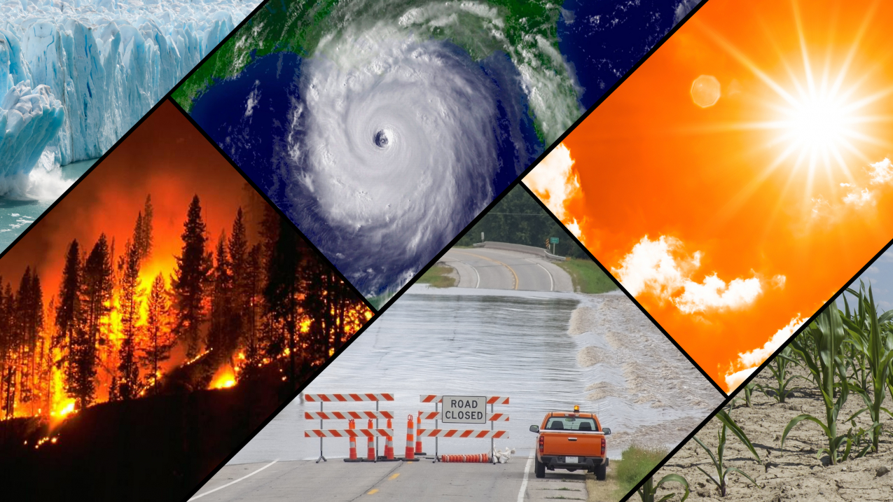

Image-1

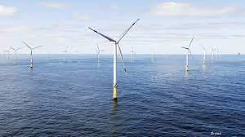

Image-2